

**BSc (Hons) in Information Technology**

**Specializing in Software Engineering**

**Year 3 - 2022**

**SE3050 – User Experience Engineering**

**Group Project**

**User Feedback**

SEJ006

Quality Education

|  |  |
| --- | --- |
| Student ID | Name |
| IT20642914 | Gamage B.G.A.C |
| IT20641092 | Wijesinha W.S.S |
| IT20637064 | Anuththara R.M.C |
| IT20639662 | Navodi P.T. |

### Table of Contents

User Feedbacks……………………………………………………………………………………………………………………………………….3

Test Script....................................................................................................................................... ...........10

Prototypes .................................................................................................................................................15 Version 2.0.................................................................................................................................................15

Evidence ................................................................................................................................................... 16

Individual Contribution .............................................................................................................................17

# User Feedbacks

We provided a google form to get feedbacks about user interfaces which we have created for our Mobile application, and we got some feedbacks through that google form.

Below snapshots show those feedbacks

*Get started Page:*

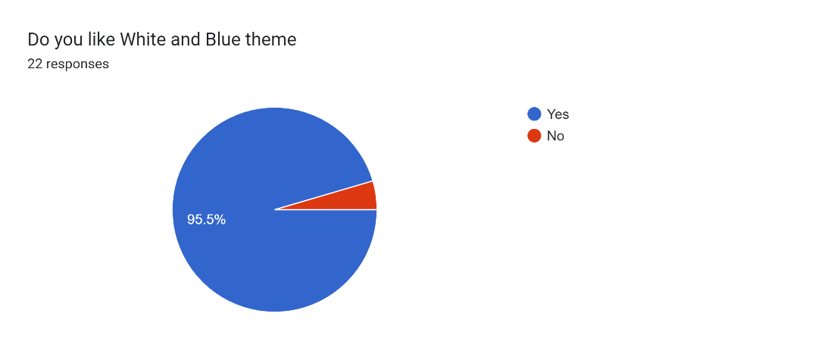

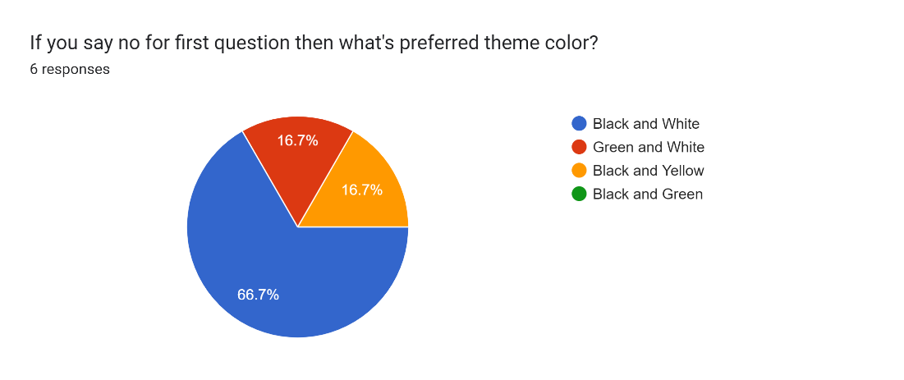

*Home Page:*

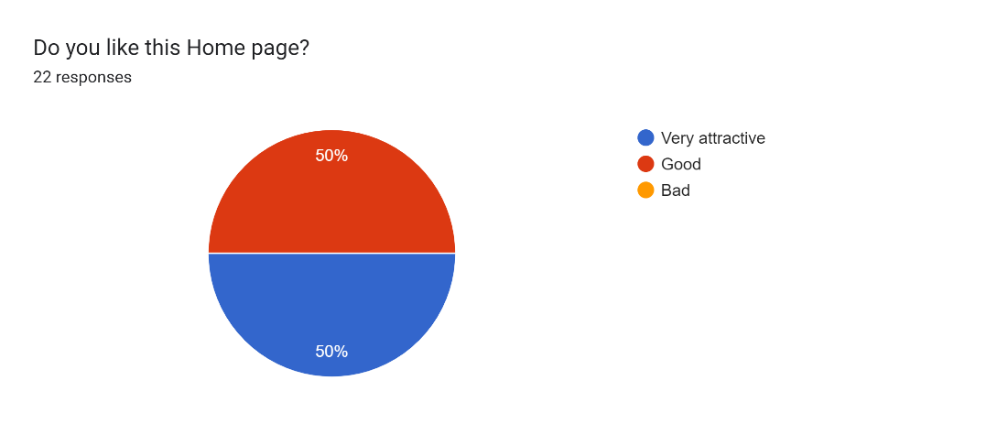

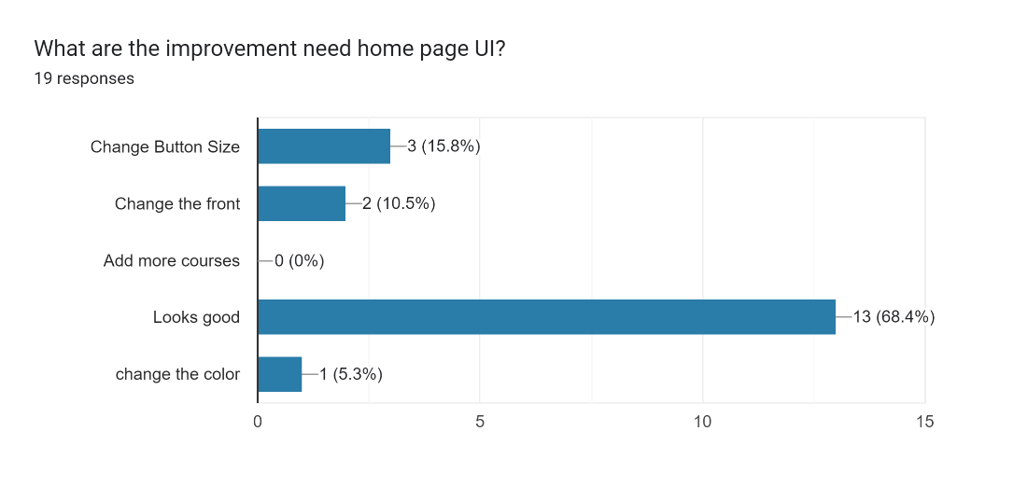

*Login Page:*

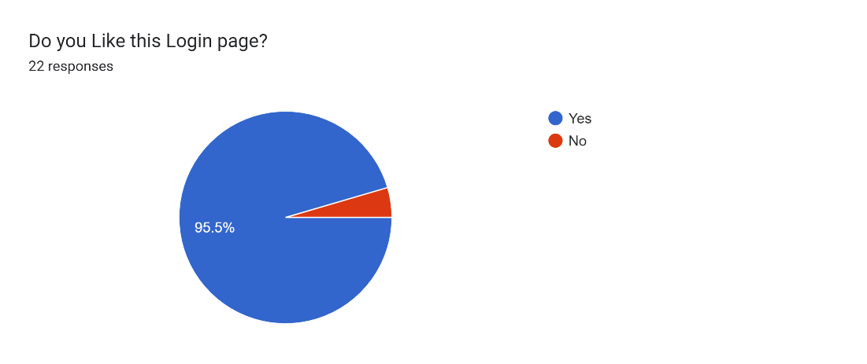

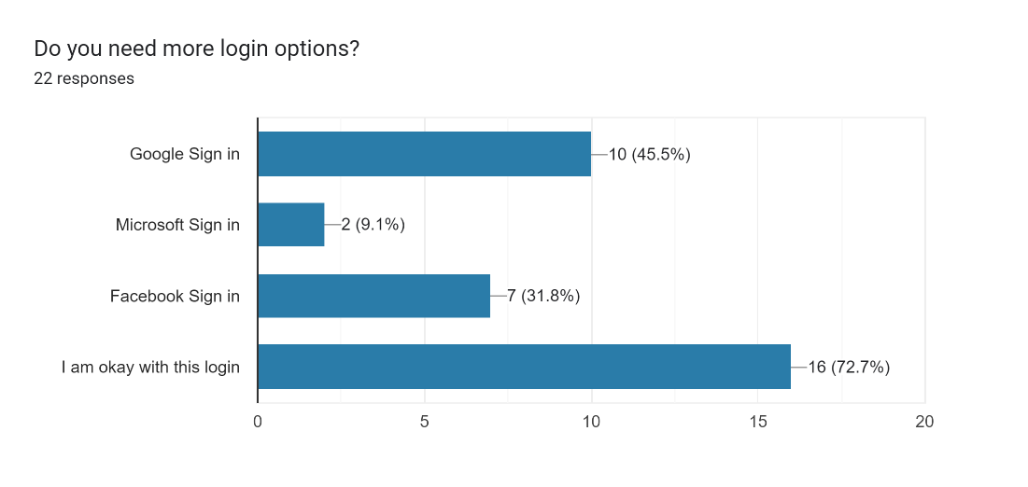

*Job vacancies View Page:*

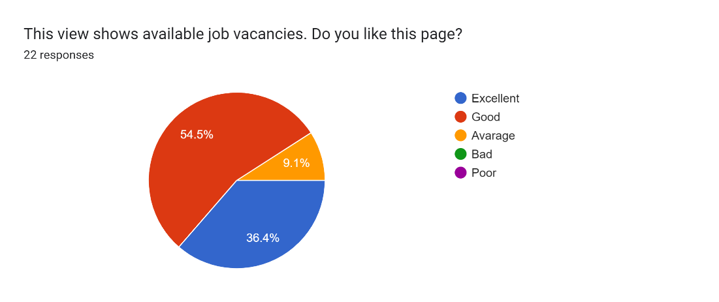

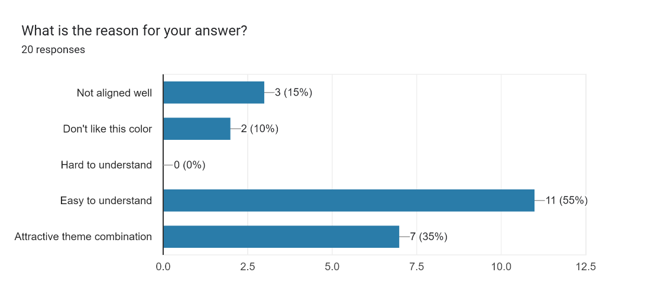

*Job vacancy in detail Page:*

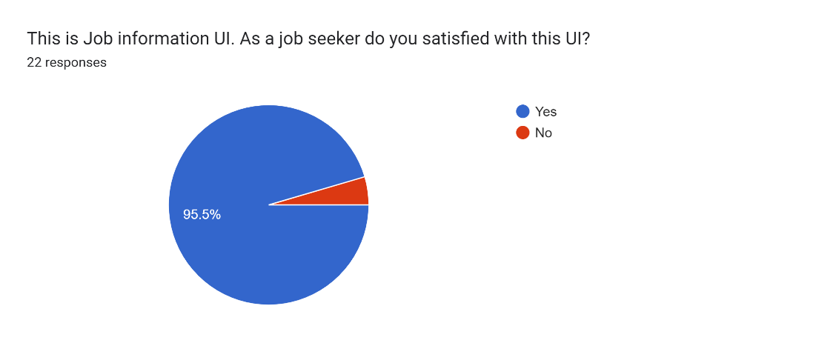

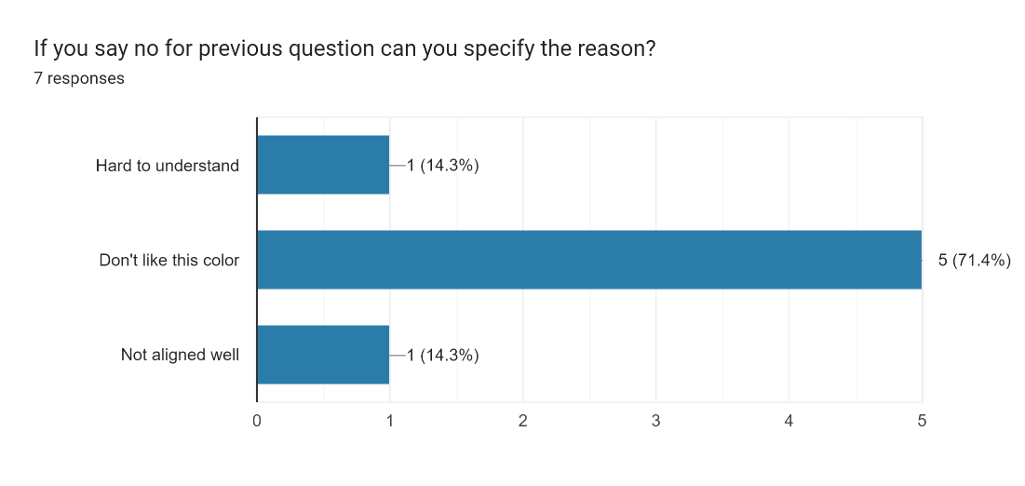

*Add job post Page:*

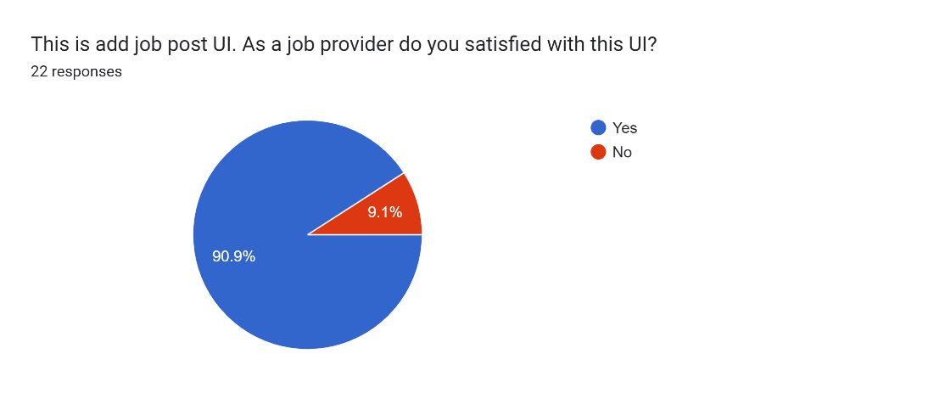

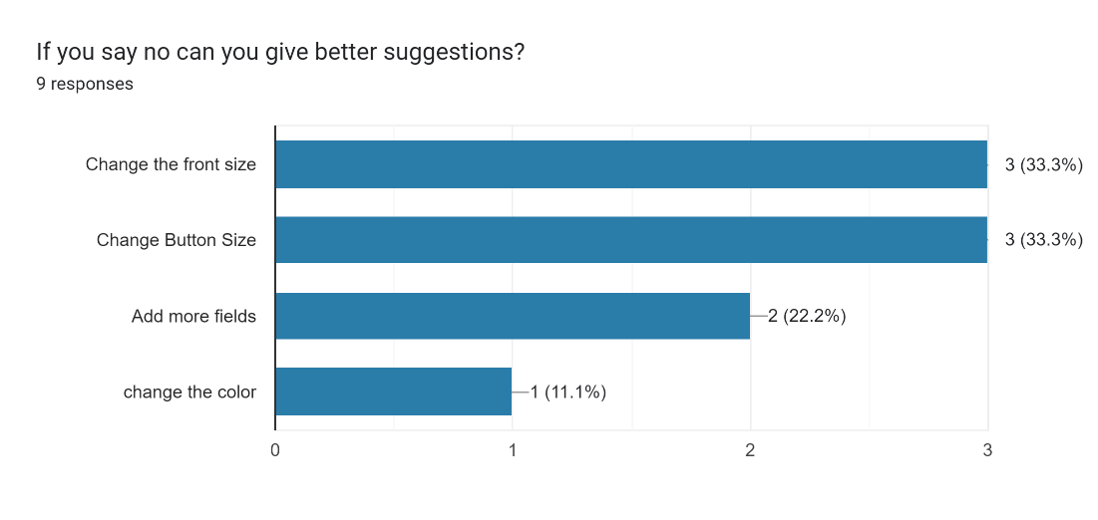

*Admin panel:*

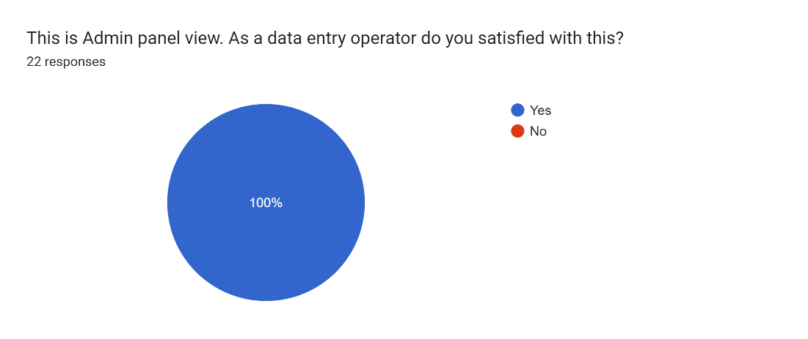

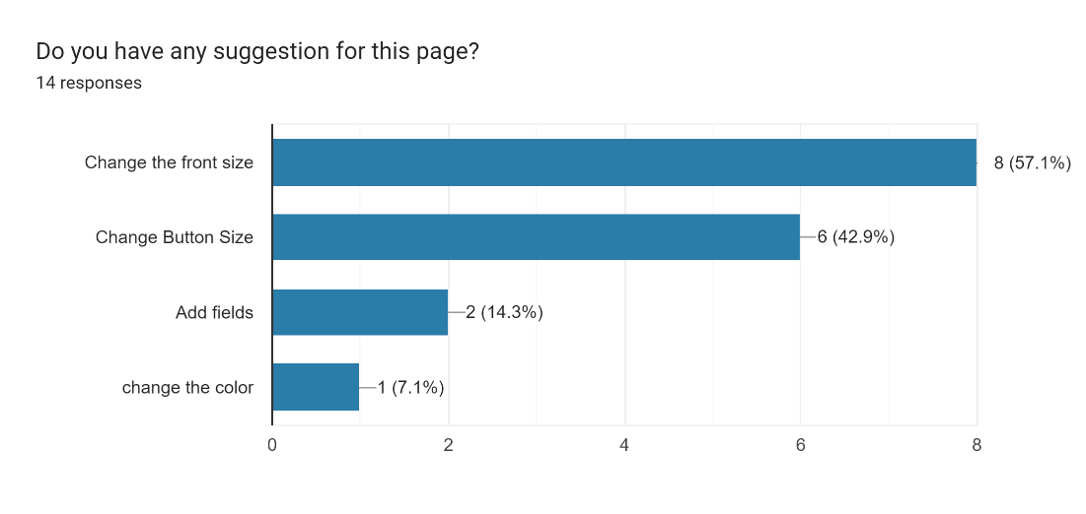

*View locations Page:*

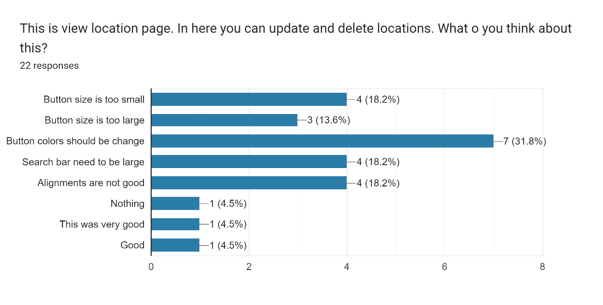

*Notify Alert:*

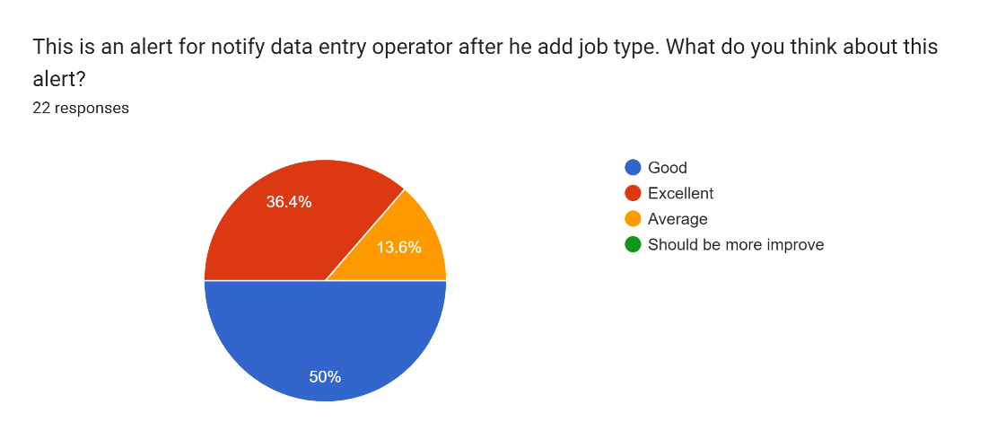

*Job articles Page:*

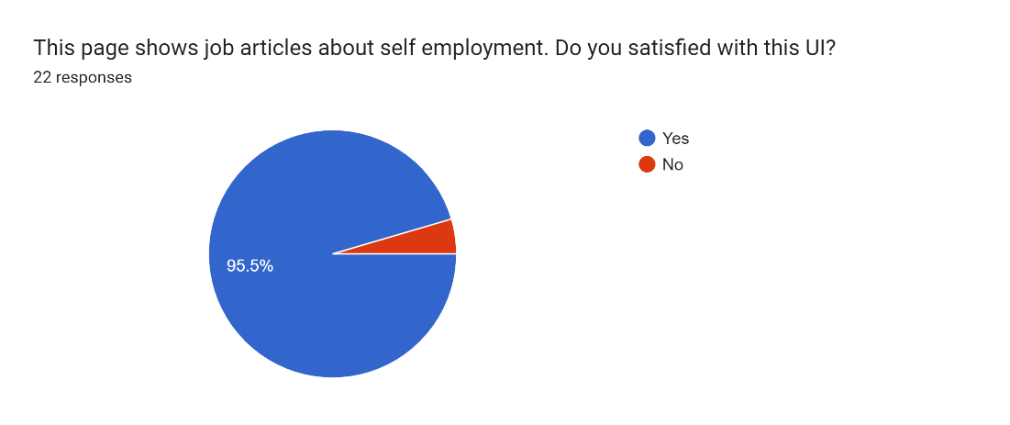

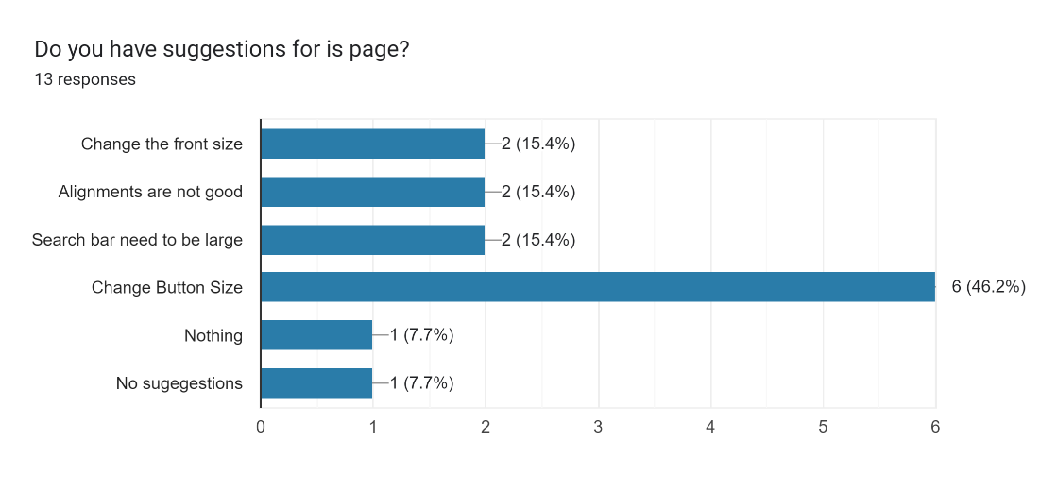

*Job article in detail Page:*

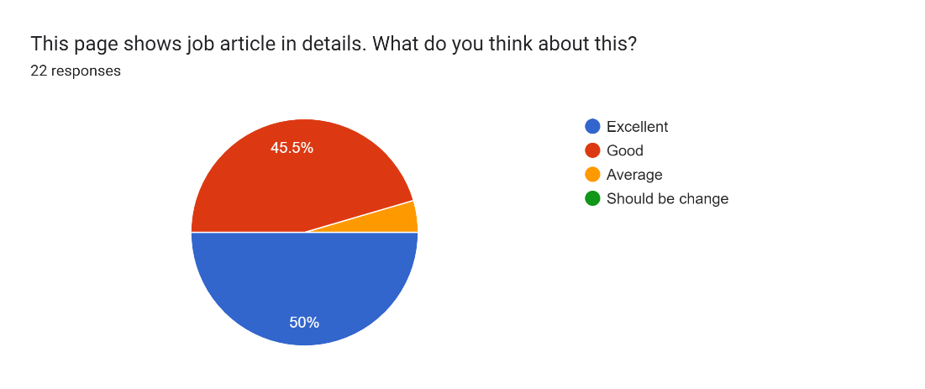

Forms response chart. Question title: What are the reasons for that answer

. Number of responses: 19 responses.

### User Feedback for prototype (Version 2.0)

# Test Script

Hi, thank you for accepting our request and for taking your valuable time to participate to our user feedback session. Before going further, I will explain briefly about this test. We have re-implemented the mobile application. So, we have come up with a new prototype. We are just testing this prototype behavior. So, please feel free to mention at any time if there’s anything you like, dislike, if you are confused etc.

#### Get started page

|  |  |
| --- | --- |
| **Question** | **Answer: Interviewer** |
| This is our get started page and when you click on the “get started” button in the bottom, you can see our home, Page. What do you think about this page? | It displays look more attractive and image is also good |
| Do you like this theme color? Blue and white | Yes. It’s nice |

#### Home page

|  |  |
| --- | --- |
| **Question** | **Answer: Interviewer** |
| This is our home page. In here we can search jobs by using this search bar and you can select any course.  What do you think about this screen? | All these screens are attractive and there are more courses than in the previous UI.  This is also same. |

#### Login page (Job provider)

|  |  |
| --- | --- |
| **Question** | **Answer: Interviewer** |
| This is our sign in page and if you want to sign in as Job provider, you can click on the “Job provider” button. What do you think about this component arrangement? | Yeah, I think it's OK and it's fine. |
| Do you have any suggestions for this page | Yeah, I think if the color combination becomes dark it’s better. |

#### Sign-up pages

|  |  |
| --- | --- |
| **Question** | **Answer: Interviewer** |
| These are our signup pages. We designed 2 signup pages for each user level. What do you think about these screens? | Yeah, using two processes for different user levels is good. It’s easy to understand. |
| Do you have any doubts or confusions on these views? | no confusions |
| Do you have any suggestions? | No, nothing for now. |

#### Add Job Post page

|  |  |
| --- | --- |
| **Question** | **Answer: Interviewer** |
| This one is “Add Post” page. Users can add their posts from this interface. Do you like this page? | Yes. It’s good look and alignments are also good |
| Do you have any suggestions? | No, I think it is simple and good. |

#### CV Generation

|  |  |
| --- | --- |
| **Question** | **Answer: Interviewer** |
| In this interface users are allowed to enter their details and generate CV according to the common template. What do you think about the components that we have used here? | I think Input fields are enough to type. It is a good idea to include the topic field and details fields both. All components are good. |
| As you can see, we have got some details from the user registration form. But they can be editable if the user wants to change some details, they can edit them. What do you think about the new view of that profile? | I think it’s better now. It is an easy method because only the details that we want to change, we can edit. |
| Do you have any confusion on this view? | No. It is good. |

#### Job Apply page

|  |  |
| --- | --- |
| **Question** | **Answer: Interviewer** |
| In this interface users can apply for a specific job by inputting user's details. What do you think about this interface? | Text is well aligned. Input fields are enough to input the details. Font size is good. And the colors that you used are good, it is comfortable to the eye.  CV upload is good. |
| Do you have any suggestions? | No, this screen is good |

**Admin Dashboard**

|  |  |
| --- | --- |
| **Question** | **Answer: Interviewer** |
| When you login as admin you will direct to the admin dashboard. What do you think about that interface? | It's simple and cool, anyone can identify the flow .so it's good |
| What do you think about colors and fronts? | Front size is good and color combination is very good |

#### My Posts page

|  |  |
| --- | --- |
| **Question** | **Answer: Interviewer** |
| This page allows the users to view their posts that have been published and we have re-arranged the alignments. What do you think about this new view? | It looks nice and user-friendly with this new view. |
| Do you have any suggestions? | No |

#### View All job Types Page/ View All Locations

|  |  |
| --- | --- |
| **Question** | **Answer: Interviewer** |
| In these two screens admin can view all added job types and locations it will allow admins to change and delete job types and job locations if they want.  What do you think about those two screens? | It is good and easy. Alignment of buttons and text are well arranged. And the color combination is good. |
| Do you have any suggestions? | No, actually both screens are good. |

#### View All Articles

|  |  |
| --- | --- |
| **Question** | **Answer: Interviewer** |
| From this page users can view all the self-employment articles. And users are allowed to search the article by using the article name. What do you think about the appearance and the functionality of this page? | Yeah, well understood when I look into this page. The search box is well positioned on the top of the page. It is good.  Font sizes are good, and posts are well arranged. |
| Do you have any suggestions? | Actually, this is good, so I don’t have any suggestions |

#### Add Article page

|  |  |
| --- | --- |
| **Question** | **Answer: Interviewer** |
| In this interface admin can add articles. What do you think about this interface? | Input fields are enough to input the details. Font size is good, and fonts are also clear. |
| Do you have any suggestions? | Actually, this is good, so I don’t have any suggestions |

#### Overall Application

|  |  |
| --- | --- |
| **Question** | **Answer: Interviewer** |
| Ok, these questions we are mainly focusing on the entire application. So, what do you think about our color icons and images that we have used? | yes, all are looking nice |
| Ok, Finally, do you have any suggestions to improve this? | I mentioned them before. Nothing more than that. |
| Ok. Then did you recommend this our app to your friends and family members? | Yes of course, If all functions are work well, I will surely recommend your app with my friends and family members |

### Prototype (Version 2.0)

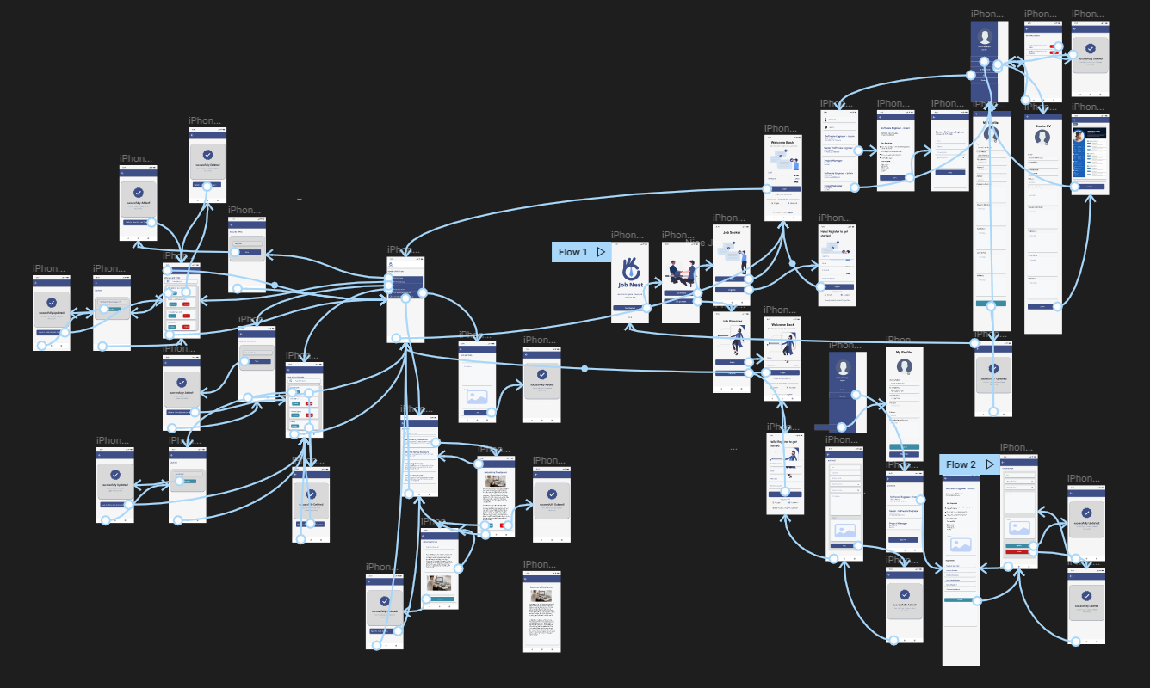

**Improvements made:**

1. Changed button and font colors
2. Changed font size
3. Added delete icon for course view page
4. Fixed alignments
5. Added more tabs for courses

## **Evidence**

**Prototype link:**

Prototype(users)= [https://www.figma.com/proto/dspgKIOvxJ4bE444SVgmeX/Untitled?page- id=2%3A2&node-id=2%3A26&viewport=806%2C41%2C0.12&scaling=scale-down&starting-point-node-id=2%3A26&show-proto-sidebar=1](https://www.figma.com/proto/dspgKIOvxJ4bE444SVgmeX/Untitled?page-%09id=2%3A2&node-id=2%3A26&viewport=806%2C41%2C0.12&scaling=scale-down&starting-point-node-id=2%3A26&show-proto-sidebar=1)

Prototype (Admins)= <https://www.figma.com/proto/dspgKIOvxJ4bE444SVgmeX/Untitled?page-id=116%3A270&node-id=183%3A304&viewport=733%2C680%2C0.12&scaling=min-zoom&starting-point-node-id=183%3A304&show-proto-sidebar=1>

**Video link:**

[**https://mysliit-my.sharepoint.com/:f:/g/personal/it20642914_my_sliit_lk/EoLxwJ98JEpJn4efekKQNkMBX8TbQKea_czNNhaf_qE0vw?e=vFhbNo**](https://mysliit-my.sharepoint.com/:f:/g/personal/it20642914_my_sliit_lk/EoLxwJ98JEpJn4efekKQNkMBX8TbQKea_czNNhaf_qE0vw?e=vFhbNo)

**Form link:**

<https://docs.google.com/forms/d/e/1FAIpQLSd5ZBxBkUNwrEE8DjIppBNVYFAFqUvVx05oCZY6V4xI-nLM1g/viewform?usp=sf_link>

**GitHUB**

[**https://github.com/avishka05/UEE-SEJ006**](https://github.com/avishka05/UEE-SEJ006)

# Individual Contribution

|  |  |  |
| --- | --- | --- |
| IT20642914(Gamage B.G.A.C) | •  • | Contributed to build the google form Contributed to build the prototype |
|  | • | Contributed to write the test script |
| IT20641092(Wijesinha W.S.S) | •  • | Contributed to build the google form Contributed to build the prototype |
|  | • | Contributed to write the test script |
| IT20637064 ( Anuththara R.M.C) | •  • | Contributed to build the google form Contributed to build the prototype |
|  | • | Contributed to write the test script |
| IT20639662 (Navodi P.T.) | •  • | Contributed to build the google form Contributed to build the prototype |
|  | • | Contributed to write the test script |